Week 2
Session 6
Task 1: Build Array from Permutation
Program:
public class Solution {
public int[] buildArray(int[] nums) {
int n = nums.length;

for (int i = 0; i < n; i++) {
nums[i] = nums[i] + n * (nums[nums[i]] % n);
}

for (int i = 0; i < n; i++) {
nums[i] /= n;
}

return nums;
}
}

Output:
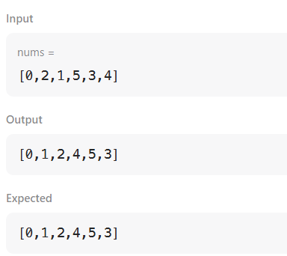

Task 2: Shuffle the Array
Program:
public class Solution {
public int[] shuffle(int[] nums, int n) {
int[] ans = new int[2 * n];
for (int i = 0; i < n; i++) {
ans[2 * i] = nums[i]; // Place x_i
ans[2 * i + 1] = nums[i + n]; // Place y_i
}
return ans;
}
}

Output:
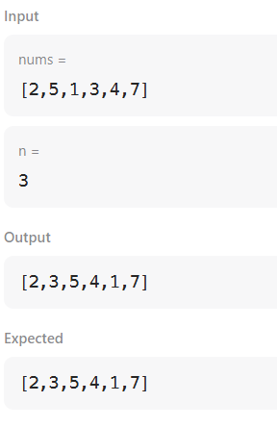
Session7
Task 1: Remove Element
Program:
public class Solution {
public int removeElement(int[] nums, int val) {
int k = 0;
for (int i = 0; i < nums.length; i++) {
if (nums[i] != val) {
nums[k] = nums[i];
k++;
}
}
return k;
}

}

Output:
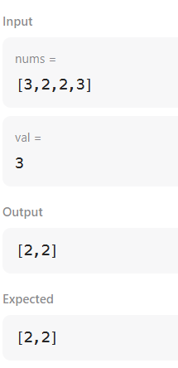

Task 2: Remove Duplicates from Sorted Array
Program:
public class Solution {
public int removeDuplicates(int[] nums) {
if (nums.length == 0) return 0;

int k = 1; // Pointer for placing the next unique element
for (int i = 1; i < nums.length; i++) {
if (nums[i] != nums[i - 1]) {
nums[k] = nums[i];
k++;
}
}
return k;
}
}

Output:
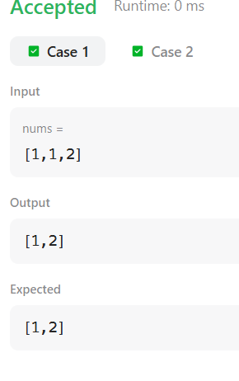
Session 8
Task 1: Maximum Subarray
Program:
public class Solution {
public int maxSubArray(int[] nums) {
int maxSum = nums[0];
int currentSum = nums[0];

for (int i = 1; i < nums.length; i++) {
currentSum = Math.max(nums[i], currentSum + nums[i]);
maxSum = Math.max(maxSum, currentSum);
}

return maxSum;
}
}

Output:
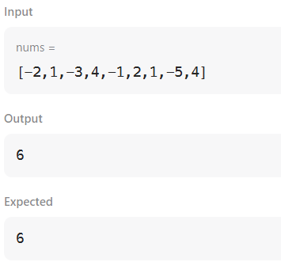

Task 2: Find the Highest Altitude
Program:
Solution public class {
public int largestAltitude(int[] gain) {
int maxAltitude = 0;
int currentAltitude = 0;

for (int g : gain) {
currentAltitude += g;
maxAltitude = Math.max(maxAltitude, currentAltitude);
}

return maxAltitude;
}
}

Output:
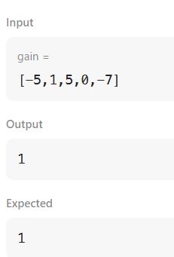

Session 9
Task 1: Group Anagrams
Program:
import java.util.*;
public class Solution {
public List<List<String>> groupAnagrams(String[] strs) {
Map<String, List<String>> map = new HashMap<>();
for (String s : strs) {
char[] chars = s.toCharArray();
Arrays.sort(chars);
String key = new String(chars);
map.putIfAbsent(key, new ArrayList<>());
map.get(key).add(s);
}
return new ArrayList<>(map.values());
}
}

Output:
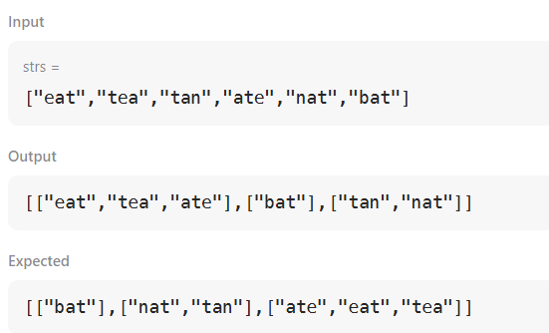
Task 2: Top K Frequent Elements
Program:
import java.util.*;
public class Solution {
public int[] topKFrequent(int[] nums, int k) {
Map<Integer, Integer> count = new HashMap<>();
for (int num : nums) {
count.put(num, count.getOrDefault(num, 0) + 1);
}
List<Integer>[] buckets = new List[nums.length + 1];
for (int key : count.keySet()) {
int freq = count.get(key);
if (buckets[freq] == null) {
buckets[freq] = new ArrayList<>();
}
buckets[freq].add(key);
}
int[] result = new int[k];
int index = 0;
for (int i = buckets.length - 1; i >= 0 && index < k; i--) {
if (buckets[i] != null) {
for (int num : buckets[i]) {
result[index++] = num;
if (index == k) break;
}
}
}
return result;
}
}
Output:
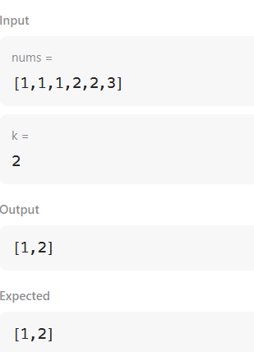

Session 10
Task 1: Java Dequeue
Program:
import java.util.*;
public class test {
public static void main(String[] args) {
Scanner in = new Scanner(System.in);
Deque<Integer> deque = new ArrayDeque<>();
Map<Integer, Integer> map = new HashMap<>();
int n = in.nextInt();
int m = in.nextInt();
int maxUnique = 0;
for (int i = 0; i < n; i++) {
int num = in.nextInt();
deque.add(num);
map.put(num, map.getOrDefault(num, 0) + 1);
if (deque.size() == m) {
maxUnique = Math.max(maxUnique, map.size());
if (maxUnique == m) {
System.out.println(maxUnique);
return;
}
int oldVal = deque.removeFirst();
if (map.get(oldVal) == 1) {
map.remove(oldVal);
} else {
map.put(oldVal, map.get(oldVal) - 1);
}
}
}
System.out.println(maxUnique);
}
}

Output:
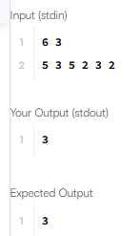
Task 2: Java Dequeue
Program:
import java.io.*;
import java.util.*;
import java.text.*;
import java.math.*;
import java.util.regex.*;

publicclass Solution {

publicstaticvoid main(String[] args) {
Scanner s = new Scanner(System.in);
int t = s.nextInt();
String [] pair_left = new String[t];
String [] pair_right = new String[t];

for (int i = 0; i < t; i++) {
pair_left[i] = s.next();
pair_right[i] = s.next();
}
HashSet<String> set = new HashSet<>(t * 2);
StringBuilder sb = new StringBuilder();

for (int i = 0; i < t; i++) {
set.add(pair_left[i] + "" + pair_right[i]);
sb.append(set.size()).append("\n");
}

System.out.print(sb);
}
}
Output:
